Ideation Phase
Brainstorm & Idea Prioritization Template

Date | 27 June 2025
Team ID | LTVIP2025TMID34066
Project Name | SmartSDLC – AI-Enhanced Software Development Lifecycle
Maximum Marks | 4 Marks

Brainstorm & Idea Prioritization Template:
In our SmartSDLC brainstorming session, we aim to foster an open and creative environment where every idea is welcomed—no matter how unconventional. Team members are encouraged to think freely about how generative AI can improve the software development lifecycle, from bug fixing to test case generation. We'll prioritize quantity over perfection, build on each other’s inputs, and later cluster ideas based on feasibility and impact. This collaborative approach will help us identify the most innovative and practical features for a smarter, more efficient development assistant.
Step-1: Team Gathering, Collaboration and Select the Problem Statement

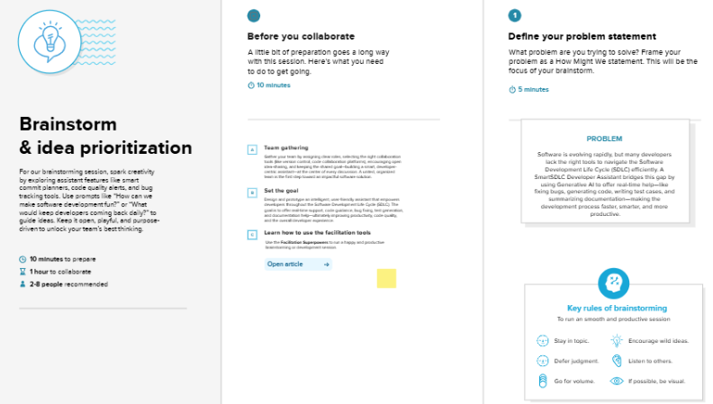

Step-2: Brainstorm, Idea Listing and Grouping
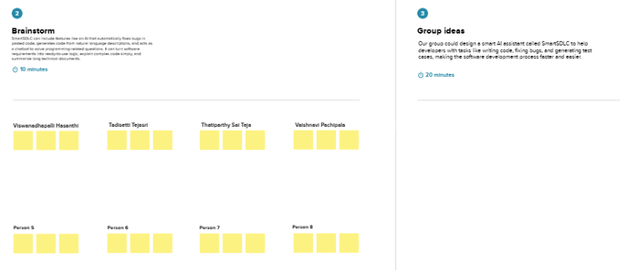
Step-3: Idea Prioritization

